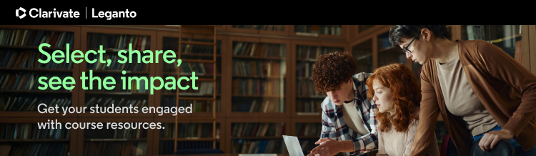

Hello, <Instructor>.
I hope this note finds you well and enjoying your week.
I want to share some information I think you might find useful

With Leganto, instructors can:
- create dynamic lists of citations from a range of sources - print or electronic Library resources, streaming video, websites, textbooks, journals, and more
- monitor student engagement through system analytics
- promote student engagement by enabling features that allows students to recommend resources and post comments
- easily update content and reuse elements or duplicate whole lists for other courses
- comply with applicable copyright policies
- fully leverage library subscriptions to enhance learning affordability
- allow selected collaborators to edit and manage lists

With Leganto, students can:
- find all of their course readings in one place, recommend resources, and post comments for discussion
- access resoures directly from the LMS – no separate log-in credentials needed, no broken links, mobile friendly
- have direct access to articles via the Leganto citation link
- save money with reading lists that greatly leverage library and campus funded materials as well as open web content.

Please reach out to me with any questions or feedback. I am here to assist and am excited to get your input as we move forward.
Warmest regards,
< Librarian>

